Neo4j Graphs

# Flight to Airport relationship graph

MATCH (n:Flights), (a:Airports) RETURN (n), (a)

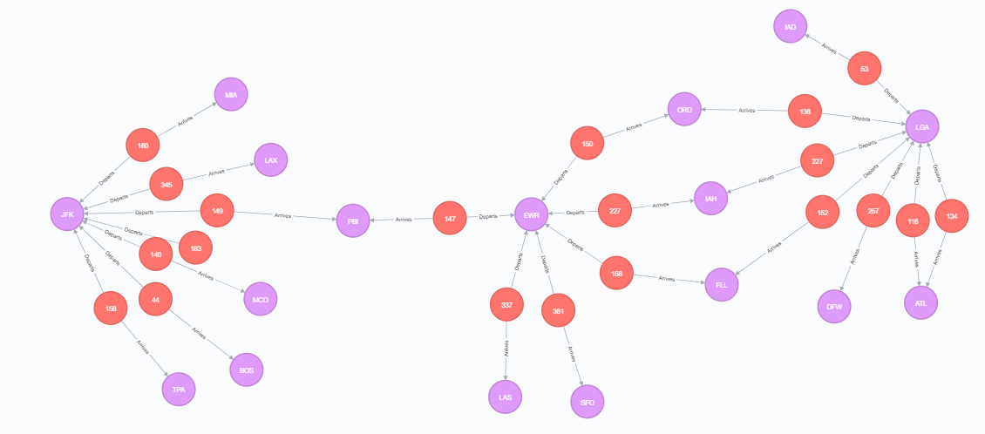

# Flight to Airline relationship graph

MATCH (n:Flights), (b:Airlines) RETURN (n), (b)

